New Gas Spreader Remote kit with built in relay and on/off switch

This unit has been programmed and tested before shipping.
ATTENTION IF THE ENGINE DOES NOT HAVE A VOLTAGE REGULATOR ON IT AT NO TIME SHOULD THE BATTERY CABLES BE DISCONNECTED OR JUMPER CABLES, CHARGERS … BE USED WHILE HOOKED UP TO THE REMOTE UNIT. USE THE ENCLOSED 10 AMP IN-LINE FUSE ON THE RED POWER WIRE. USE THE SAME GUAGE OF WIRE. IF THE BATTERY CABLES BECOME DISCONNECTED THE ENGINE WILL SEND OVER 60 VOLTS TO THE RECEIVER UNIT AND BURN THE UNIT OUT which voids 90-day warranty. No warranty on burnt circuit boards.
Use a test light to locate the proper oem wires for connection to the wireless unit.
Kit includes
1-receiver base unit
1-transmitter
1-10amp in line fuse line
1-relay -built in
1-relay socket – built in

Yellow wire is activated by button #1 Latch/Unlatch – clutch conveyor / spinner on off (L) This will run through the built in relay
Blue wire is activated by button #3 Throttle control (throttle UP) (U) button
Green wire is activated by button #4 Throttle control (throttle DOWN) (D) button
Brown wire is activated by button #5 Momentary engine start (E) button
Orange wire is activated by button #6 Momentary to ground/kill motor (STOP) button
Red wire is DC power supply Black wire is DC ground
MAKE SURE YOU HAVE SECURE AND CLEAN CONNECTIONS EVERYWHERE. Do not hook up any other accessory to the remotes power and ground wires.
This unit will replace your oem controller. Before installing locate and be familiar with the original equipment wiring to assist in where to attach the wires from this unit.
Use the on off switch to turn the receiver off and on. If the unit is left on unattended for a long length of time it will discharge the power source.
Intended usage: off road use only. We have no control over the end usage of the wireless units.
Use only. We offer no written or expressed liability as to how this unit is used

For Reprogramming or replacement transmitter programming only (unit comes programmed) instructions.
PROGRAMMING Set-up and operation. Video link
Note you need to be next to the receiver with cover off and the receiver needs to have 12-volt power and ground connected. The LED will be lit if power and ground are properly connected.
On the backside of the standard Transmitter, use a paperclip and GENTLY insert it in the hole next to the clear blue window. Once the programming button is depressed, a blue LED will begin to blink for 15 seconds. Flip the Transmitter over and firmly depress all 8 buttons one at a time button within 15 seconds while the light is still blinkiing. Now the Transmitter has acquired a 1 in 16 million address. MAKE SURE THE BLUE LIGHT GOES OUT BEFORE PROCEEDING.
With the receiver connected to a 12VDC power source look inside the box next to the red LED depress the black programming button. The red LED will begin to flash for 15 seconds. Take the Transmitter while the red LED is flashing and depress all buttons one at a time on the transmitter. When you are finished press the black button on the receiver again and the red light will stop blinking and you are now programmed. To test this press a button on your transmitter and the red light on the receiver will come on. Re-install the cover noting drain hole position,

Add/create button

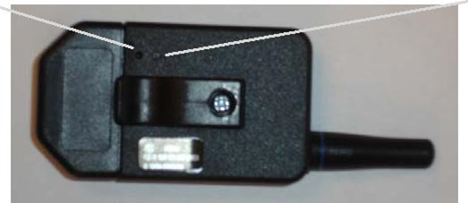
Blue light

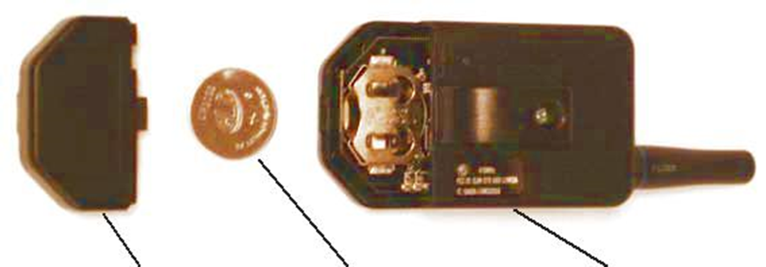
TRANSMITTER
2032 battery
COVER

Battery Replacement
The transmitter uses a standard lithium button cell battery. In normal use, it will provide at least 2 to 3 years of operation. To check the battery simply depress gently into the learn hole to replace the battery, gently pry the battery cover off. Remove the battery by tapping the transmitter on a bench/desk to dislodge the battery then remove by hand. Observe the battery polarity when replacing. Once the battery is replaced, test by inserting paperclip into Add / program hole and depress lightly and remove paperclip. If the light begins blinking the battery and transmitter are ok. Repeat programming steps to set a new address between the transmitter and the receiver / base unit.
Learn address from transmitter button LED Switch

